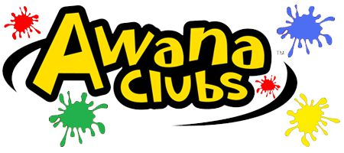

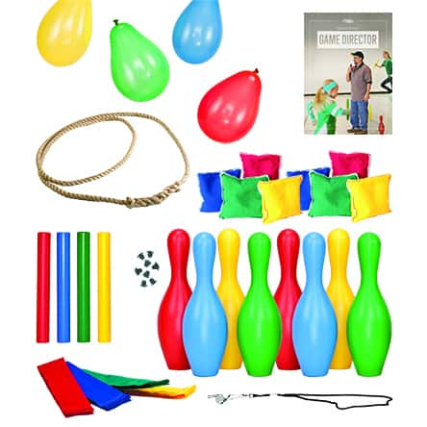
AWANA ACTIVITIES

Game Time:

high energy, exciting games played outdoors or indoors on the AWANA game circle. Game time promotes fun, exercise, good sportsmanship, and an opportunity to excel. Winning teams receive AWANA Dollars and special recognition.
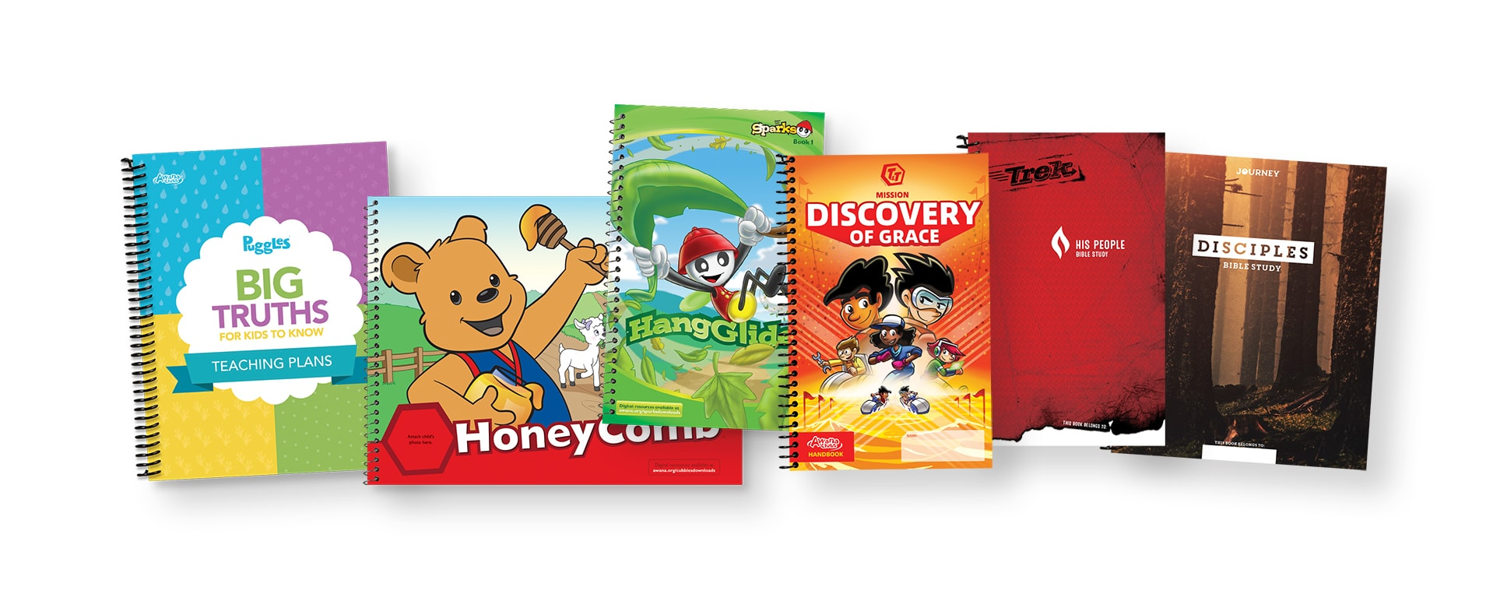

Small Group/Handbook Time:

Clubbers work in small groups with other clubbers in their grade and book with a leader. The leader will lead the small group time and help clubbers learn their verses. The leader and listeners will listen to completed sections and sign-off in their handbooks. After a section is completed, the clubber will receive AWANA dollars and will be able to go to the reward room.

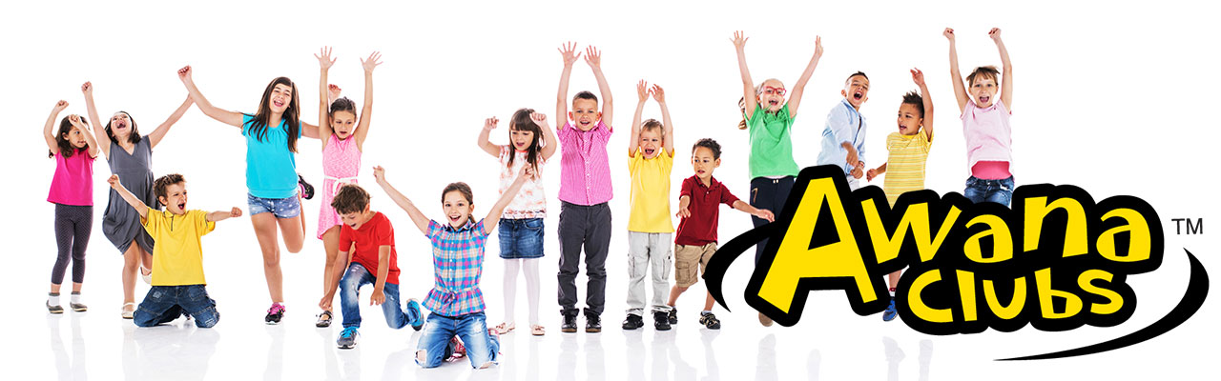
Large Group Lesson Time: An interactive, age-appropriate Bible lesson, worship and/or prayer time. Large Group Lesson will include the Gospel presentation and other biblical truths. It provided an opportunity for clubbers to share praises and prayer requests. At the end of Large Group Lesson time, clubbers will receive their awards for the week.
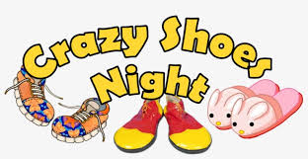

Theme Nights: A monthly flier and email will be distributed to announce Theme Nights! Theme Nights may include Crazy Hair Night, PJ Night, or Tacky Night. We love for all our clubber to participate and share in the fun we have at CDO .
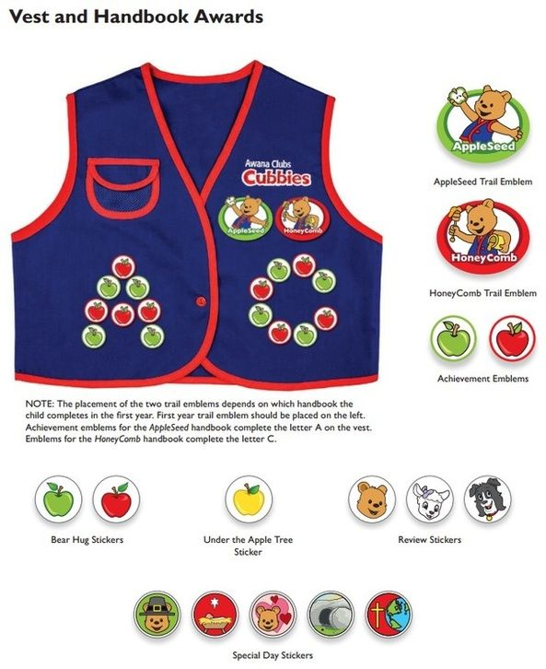

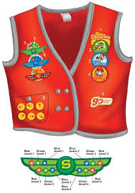
What to wear: Each clubber should receive their AWANA uniform or vest each night to receive recognition and incentives. In addition, please have your clubber wear pants or short and ATHLETIC SHOES with ties or Velcro. Please note that ATHLETIC SHOES with ties or Velcro are required for your child to participate in Game Time. Croc, sandals, flip-flops, Toms, boots and bare feet can cause injury to your child as well as other children. Please help us with this concern and have a pair of tennis shoes available for your clubber on Wednesday nights!

What to bring: *Your AWANA Handbook * Your Bible * Your Uniform * Jacket for outdoor activities in cool weather * A Friend!

